  
BEEE LAB EVALUATION

NAME : Nishant Kumar

UID : 19BCG1022

SECTION : CSE (G&G)

SUB: BEEE LAB

***Circuit diagram***

Evalutaion question

Design an automatic night lighting system such the system is only activated when the master control switch is pressed. a) Below 50% value of full brightness led blinks with a freq. of 500 msec. b) Above 50% value of full brightness led blinks with a freq. of 100 msec.

Theory

***image***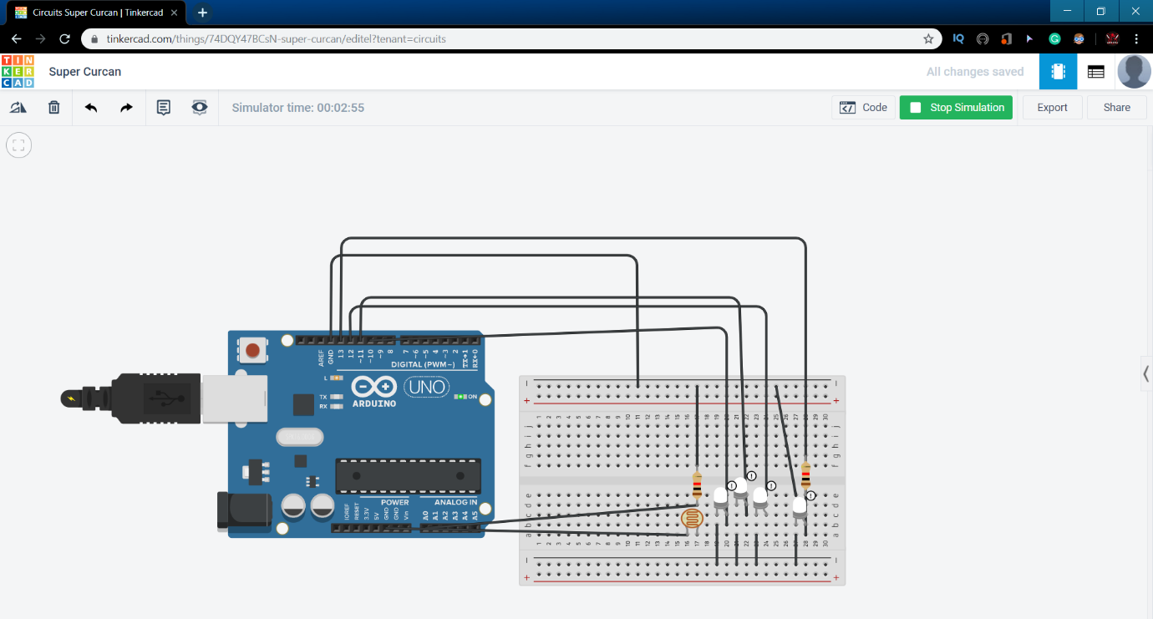

***Setup code***

***int value = 0;***

***void setup() {***

***Serial.begin(9600);***

***pinMode(10, OUTPUT);***

***pinMode(11, OUTPUT);***

***pinMode(12, OUTPUT);***

***pinMode(13, OUTPUT);***

***pinMode(A0, INPUT);***

***}***

***void loop() {***

***value = analogRead(A0);***

***if (value>129)***

***{***

***digitalWrite(10, HIGH);***

***digitalWrite(11, LOW);***

***digitalWrite(12, LOW);***

***digitalWrite(13, LOW);***

***delay(100);***

***}***

***else if (value < 128) {***

***digitalWrite(10, HIGH);***

***digitalWrite(11, HIGH);***

***digitalWrite(12, HIGH);***

***digitalWrite(13, HIGH);***

***delay(500);***

***}***

***}***

Learning & Obersevation

`While experiment we oberseve the the led is blinking when programmed and if its brightness is less than 50% ,it shows full brightness and above 50% it shows one led glows with full brightness.

**problems & troubleshooting**

the work has to be done properly as it is much sensitive .it needs proper attention.

**Outcomes**

If the brightness sense by the LDR is below 50% value of full brightness led glows.

and if the brightness sense by the LDR is above 50% value of full brightness only one led glows with full brightness.